**Coding Challenge**

Q3. Write a Java program to print a pyramid pattern of alphabets, starting from 'A', using spaces. A BCD EFGHI JKLMNOP QRSTUVWXYZ

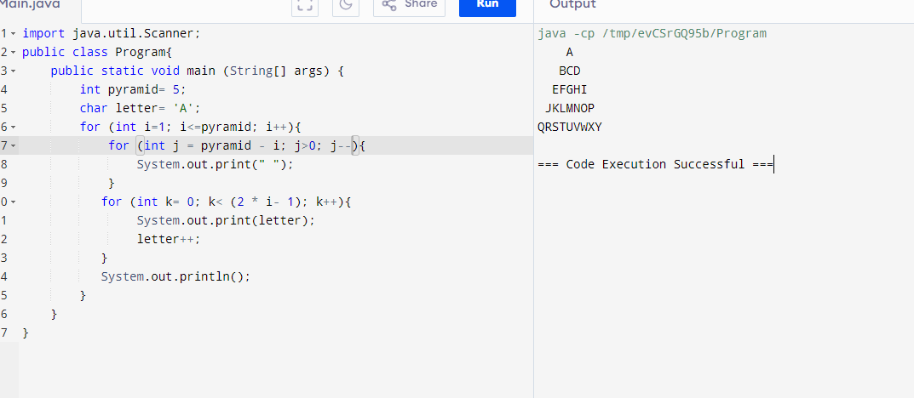

Q4. Write a Java program to print a hollow right triangle pattern using numbers and spaces.

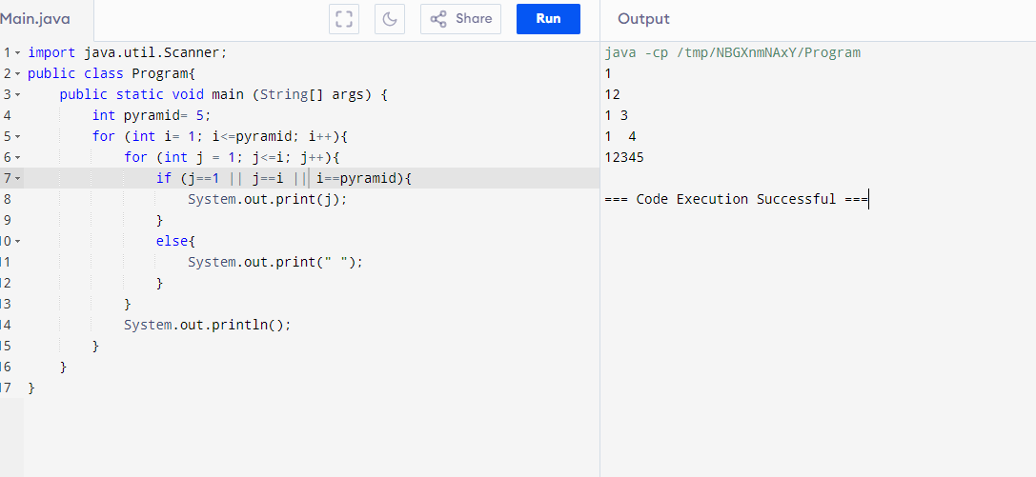

Q5. Write a Java program to print a Palindrome Number Pyramid.

